

**Submitted By:-**

**ISHIKA PUNCHARIYA**

**XII – A (I – Shift)**

**Roll No. __________________**

**Submitted To:-**

_________________________

**Mrs. Chandrakiran Satdeve**

**(PGT Computer Science)**

INDEX

**S. No. Description Page No.**

1. Certificate 4
2. Acknowledgement 5
3. Introduction 6
4. Objectives 7
5. Hardware and Software 8

Requirements

1. Entity Relationship(ER) 9

Diagram

1. Flowchart 10
2. Modules used 11
3. SQL – Coding 12
4. Source Code 13
5. Modules 18
6. Output 26
7. Bibliography 32

CERTIFICATE

This is to certify that **Miss Ishika Punchariya** of class XII-A, Roll no. _______________ has completed her project work entitled **“BANK MANAGEMENT”**, as a part of the paper of COMPUTER SCIENCE under my supervision and guidance. To the best of my knowledge, it is an original piece of work once is worthy of consideration in practical fulfillment of the requirement of CBSE, Delhi for the award of senior school certificate in science for the session **2019- 2020**.

**Signature of Internal Examiner**

**Signature of External Examiner**

**PRINCIPAL**

ACKNOWLEDGEMENT

It is with great pleasure that I find myself penning down these lines to express my sincere thanks to various people who helped me a long way in completing this project.

My sincere thanks to our principal, **Mr. Satish Kumar** who provided us harmonious climate in our school for preparing the project. It was a privilege to have been guided by **Mrs. CHANDRAKIRAN SATDEVE** (PGT Computer Science).

Thanks to all my classmates who helped me during the development of this project with their constructive criticism and advice.

INTRODUCTION

The project on ‘BANK MANAGEMENT’ describes the main activities that are performed in a bank but utmost care has been taken to make the system efficient and user friendly.

With this system both the users namely customer and employee of a particular bank will find it easy to use and able to perform their operations.

This project is made to maintain records and data of customers in a database by employees and provides facilities for customers to look up on their account situations.

This computer-based management system is designed to handle all the primary information required.

OBJECTIVES

The main objective of this project is to provide flexible solution to the banking industry. The project on ‘BANK MANAGEMENT’ has been designed to computerize the following facilities:

**1. Opening a new account**

**2. Transaction records**

**3. Fixed deposit**

**4. Loan sanction**

**5. Closing the existing account**

The basic objective of this project is to simplify the day to day activities of a bank and to provide fast, efficient and reliable system.

HARDWARE & SOFTWARE REQUIREMENTS

HARDWARE REQUIREMENTS

* Windows 7 Ultimate
* 32-bit Operating System
* 2 GB RAM
* Intel® Pentium® D CPU 2.80GHz Processor

SOFTWARE REQUIREMENTS

* Python 3.8 32-bit
* MySQL 5.6.26

ENTITY RELATIONSHIP DIAGRAM

**IN**

**FROM**

**TAKEN**

**FROM**

**IN**

FLOWCHART

MODULES USED

* MySQL-Connector

Customer login:

* Acc_opening
* Transaction
* FD
* LOAN
* Acc_ClosingEmployee Login
* Dep_wthd
* FundTransfer
* Loan

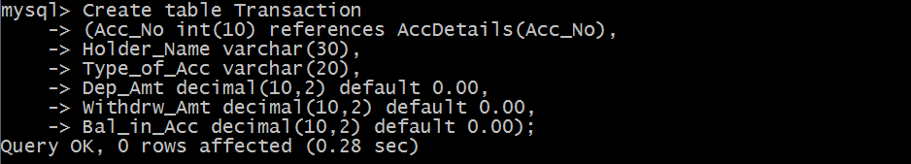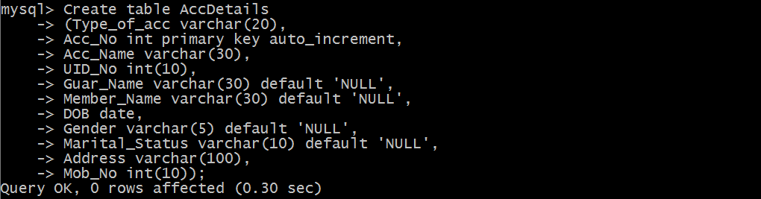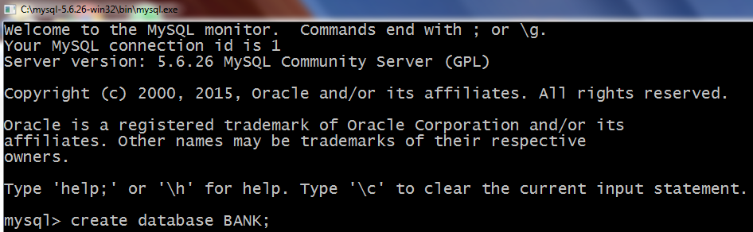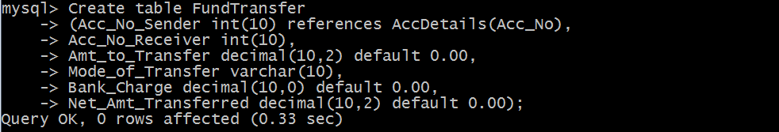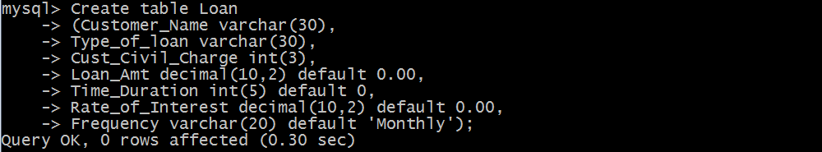SQL CODING

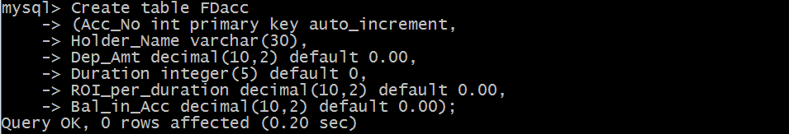

SOURCE CODE

MODULES

Customer Login

* Account opening
* Transaction
* FD Account
* Loan
* Account Close

Employee Login

* Deposit - Withdraw
* Fund Transfer
* Loan

OUTPUT

BIBLIOGRAPHY

* Computer Science with Python by Sumita Arora – Textbook for class XI
* Computer Science with Python by Sumita Arora – Textbook for class XII